Troubleshooting Guide for EyeDetect Manager and EyeDetect+ Manager
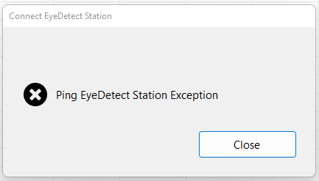
This document provides a quick overview of possible resolutions to technical issues related to the EyeDetect Manager or EyeDetect+ Manager software error “Ping EyeDetect Station Exception” or others.

We suggest trying all steps regardless, to make sure everything is up to date.

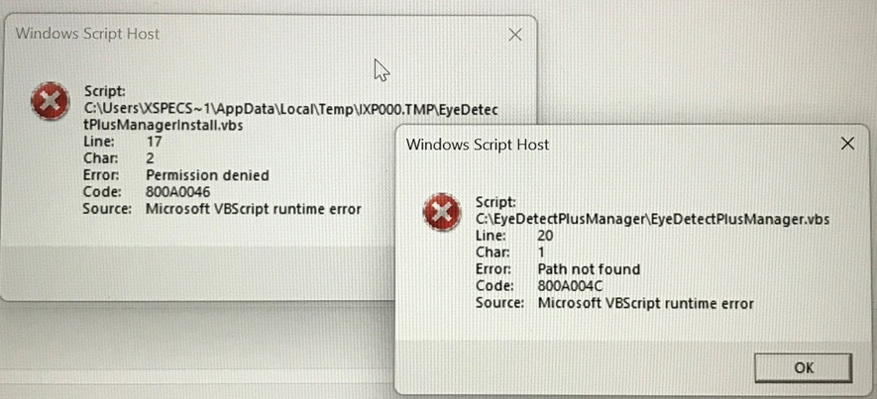

Possible issue: data streaming not enabled on Station.
- Solution: Open EyeDetect app.
- Go to File>Settings
- Under “Settings” make sure Enable Data Streaming API has a checkmark in the box.

Possible issue: device compatibility
- The device on which you have installed EyeDetect Manager is not compatible or must have Windows 8 or higher (WIN10 preferred), wireless internet capabilities or screen resolution of1200 x 800 minimum.
- Solution: Use a different device.

Possible issue: downloaded device
- Possible issue: the EyeDetect Manager software was downloaded onto an EyeDetect station, not a separate Wndows device.
- Solution: Use a different device. EyeDetect Manager cannot operate on an EyeDetect Station while a test is administered.

Possible issue: update to latest version of EyeDetect Manager software
- Possible issue: The device doesn’t have a copy of the latest version of software.
- Solution:
  - Login to Converus dashboard
  - Go to the Tools menu
  - Click EyeDetect Manager (or EyeDetect+ 2.0 Manager) to automatically download.
  - Click on downloaded application to run in your browser.
  - It will automatically open the application.
- Run EyeDetect Setup- after downloading Manager.
  - On the Station, go to This PC>C:>DataLocker>Converus>EyeDetectSetup and run the EyeDetect Setup Application by clicking on it.
  - Click Yes to let it make changes to your computer.

Possible issue: troubleshooting network settings
- Possible issue: the IP Address on the station has changed.
- Solution: Find the new IP address and enter it in EyeDetect Manager.
  - Open the EyeDetect app.
  - Go to File>Settings
  - Add the IP address under Check “Enable Data Streaming API.”

- Possible issue: the device using EyeDetect Manager is not on the same Wi-Fi network as the Station.
- Solution: Check Wi-Fi on both devices
  - Click on the internet icon on the bottom right of the task bar.
  - Ensure both devices are connected to the same network.

- Possible issue: the Wi-Fi settings no longer marked as “Private”
- Solution: Go to Windows Settings
  - Select Network & internet
  - Select Properties at the top
  - Select Private

- Possible issue: the current internet connection has custom IP settings.
- Solution: Check by opening a Command Prompt and typing in tracert IP [Address you are trying to connect]. If it says Destination host unreachable, check the internet connection or switch as well.

Time Zone

- Station and device with EyeDetect Manager not on same time zone
- Solution:
  - Go to Date & Time settings for Windows
  - Check that Time zone is the same
  - Even if Set time automatically is enabled, you may have to disable it to manually change the time zone.
  - Make sure to Scroll down to Additional Settings and click on Sync Now
  - If Time zone is disabled you will need to go Privacy & security > Location Then from there turn on Location Services

